BEACON ELIGIBILITY VERIFICATION
Steps to verify:
- Go to https://provider.beaconhealthoptions.com/login.aspx and login.
- Click Eligibility/Benefits and use client name, DOB, and Subscriber ID# check eligibility.
- BOTH places must say yes for client to be eligible:
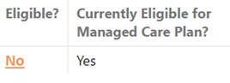
- Click on Yes or No under eligible to see coverage dates:
